**PEOPLE OF THE HAUDENOSAUNEE**

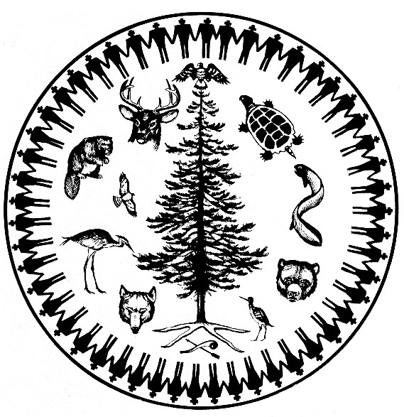

**CONFEDERACY RESPONSE TO THE FEDERAL FRAMEWORK LEGISLATION**

**MAY 2019**

## *PREAMBLE*

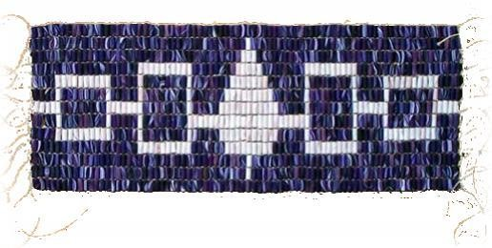

The Haudenosaunee or *People of the Longhouse* are sovereign Peoples composed of six Indigenous Nations; often referred to as the Six Nation Iroquois Confederacy.

The Nations are:

* The Mohawk Nation
* The Oneida Nation
* The Onondaga Nation
* The Cayuga Nation
* The Seneca Nation
* The Tuscarora Nation

The Haudenosaunee are a constitutional democracy that has existed since time immemorial and are governed by the Kaianerekowa; the Great Law of Peace. Within this Constitution, the

Kaianerekowa, the Haudenosaunee serve as the traditional custodians of sovereignty and enjoy the freedoms and liberties including the ability to determine citizens of the Haudenosaunee.

## HAUDENOSAUNEE – CROWN RELATIONSHIP

Throughout its evolution, Canada has attempted through policies and legislation including the Indian Act to implement unilateral control of Haudenosaunee lands, jurisdiction, governance and attempting to define the Haudenosaunee as “status Canadian Indians”. The most recent attempt of assimilation by Canada is through the Recognition and Implementation of Rights Framework.

The enduring relationship between the Haudenosaunee and the British Crown is well-defined through the two treaties entered into by the two sovereigns. These treaties being the Silver Covenant Chain and the Tekni Yohate Guswenta (Two Row Wampum).

These Treaties with the Crown define Canada’s relationship with the Haudenosaunee. Canada has evolved into its role as the administrator of the Crown-Haudenosaunee Treaty relationship without the consent of the Haudenosaunee. As the administrator of the Crown-Haudenosaunee relationship, Canada has the obligation of maintaining the honor of the Crown and upholding the Treaty commitments by acting as the liaison with Haudenosaunee on behalf of the Crown. This liaison responsibility is acknowledged by Canada with the continued maintenance of the Governor General of Canada as a part of the Canadian legislative process.

### RELATIONSHIP WITH THE CROWN

#### THE SILVER COVENANT CHAIN

The Silver Covenant Chain defines the relationship between the Crown and the Haudenosaunee Confederacy. The Silver Covenant Chain is a symbol to each of our Nations that by holding the covenant chain they share the responsibility that binds our friendship so that the two Nations may walk upon this earth in peace, trust and friendship. The Crown’s symbol for this treaty was a covenant chain made of three silver links. The first link represented peace between us. The second link represented having a good mind. The third link was a symbol of eternal friendship.

The Silver Covenant Chain was to remain pure, strong and untarnished, to bind our Nations together without causing them to lose their respective independence. As each of our Nations hold the Covenant Chain, each Nation is responsible for keeping the relationship bright by not allowing tarnish to develop thus preventing the chain from breaking.

The Covenant Chain binds our Nations in a relationship of friendship and mutual co-existence as separate independent nations. The Haudenosaunee reminds the Crown, the Silver Covenant Chain which defines the original and ongoing relationship between the Haudenosaunee and the Crown, is based on the principles of peace, trust, eternal friendship and a good mind.

It was agreed that should the chain become tarnished the two Nations would sit together to polish the links and renew the treaty, the Silver Covenant Chain.

#### TEKNI YOHATE GUSWENTA



When the Haudenosaunee first encountered representatives of the Dutch, they found that the Dutch were unaware of the principles of the Haudenosaunee; and this lack of awareness had the potential of disrupting the peaceful ways in which the Haudenosaunee People lived. As such, the Haudenosaunee entered into a treaty of peace, respect and peaceful co-existence, known as the Tekni Yohate Guswenta, or Two Row Wampum Belt, which formed the foundation for subsequent treaties with the French, the British, and the Americans.

The Belt was made with two parallel rows of purple wampum on a bed of white beads. The white symbolized the purity of the treaty and represented the river of life that each Nation travels through time. The two separate rows of purple beads were made to symbolize and encompass the spirits of Haudenosaunee and non-Haudenosaunee people and their ancestors. Between the two rows of purple beads, three rows of white beads were placed. These were made to stand for the Friendship, Peace and Respect between the two Nations.

The two rows of purple beads further symbolize the two Nations of people are parallel to each other in separate vessels as they travel the river of life. The Onkwehonwe (Haudenosaunee) are in their canoe which symbolizes the Haudenosaunee culture, laws, traditions, customs, and way of life.

The non-Onkwehonwe people are in their ship, which symbolizes their culture, laws, traditions, customs and way of life. Each Nation shall stay in their own vessel and travel the river of life side by side. Further, neither Nation should try to steer the vessel of the other, or interfere or impede the travel of the other.

The Tekni Yohate Guswenta affirms and recognizes the ongoing relationship between the Crown and the Haudenosaunee. This relationship is based on the international right of each Nation to govern and manage its own affairs, including the determination of Haudenosaunee Citizenship in an environment based on peace, friendship and respect.

## HAUDENOSAUNEE CITIZENSHIP

Haudenosaunee citizenship is enshrined within the Covenant Circle Wampum. That being, one is born within the protection of the Confederacy and Haudenosaunee citizenship is conferred by being born of one of the forty-nine clan families that exist within that circle wampum.

To be clear, Haudenosaunee citizenship is conferred in one of two ways; by birth into one of these matrilineal clan families or through an adoption into one of these matrilineal clan families.

### COVENANT CIRCLE WAMPUM

The Circle Wampum symbolizes the intricate system of relationships that exist amongst the Haudenosaunee Confederacy. The orientation of the circle and its 50 strings replicates the Loyane of the original Five Nations. The strings that hang from the top of the circle, represent the Onondaga Nation, Firekeepers of the Confederacy. On the left and lower left are the two other Elder Brothers; the Mohawk Nation and the Seneca Nation. On the right and lower right are the Younger Brothers; the Oneida Nation, the Cayuga Nation and the Tuscarora Nation.

Along the circumference of the circle are two intertwining strands, symbolizing the joined arms of the Loyane and their responsibility to oversee and protect the jurisdiction, the political and spiritual ways of the Haudenosaunee. Within the protective domain of this circle, exists the national characteristics that define the Haudenosaunee as Peoples and as Nations.

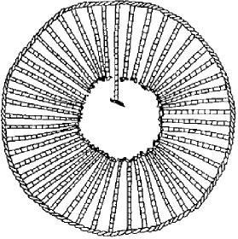

### CONTEMPORARY CITIZENSHIP ISSUES

Following the arrival of Europeans, the succeeding colonial regimes targeted the matriarchal foundation of Haudenosaunee identity. The Haudenosaunee Clan families were bombarded by assimilation policies designed to extinguish the spiritual, emotional, mental, social norms, and the governance and cultural structures of the Haudenosaunee.

The Haudenosaunee have experienced the ongoing brunt of colonial contact and infiltration. From the introduction of Christianity to the emergence of patrilineal identification imposed through Canada’s Indian Act, numerous generations of intermarriage resulted in a significant absence of clan identification experienced by many families of each nation of the Haudenosaunee.

In addition to complications and difficulties that have arisen through the interruption of our clan system through intermarriage, the Haudenosaunee has also experienced deep rooted spiritual clashes as many faiths are practiced by Haudenosaunee nationals within the Haudenosaunee Nations which are inconsistent with the principles established through the Kaianerekowa and found within the Covenant Circle Wampum.

As such inconsistencies and clashes are the result of colonial attempts to assimilate and absorb our people, it must be recognized that it is the responsibility of the Haudenosaunee to follow the Kaianerekowa to re-assimilate People back into the Covenant Circle Wampum.

The Haudenosaunee have historically maintained a policy of inclusivity in order to replenish its population so that it can maintain its social, political, spiritual fabric; the nature of Haudenosaunee jurisdictional integrity, a way of life.

### CITIZENSHIP CRITERIA

The Haudenosaunee Grand Council of Chiefs reject blood quantum as determining Haudenosaunee citizenship. The Clan system is fundamental to being Haudenosaunee and is an essential part of the way of life, to the Great Law and the Ceremonies that bind the Haudenosaunee Confederacy as one.

The Kaianerekowa confirms, there are two ways that one is recognized as a Haudenosaunee citizen:

1. Persons born of a Haudenosaunee mother. A person is considered a Haudenosaunee citizen at birth provided that he or she is born of a mother who is considered to be a Haudenosaunee citizen with a Haudenosaunee clan transferred at birth.

2. Persons adopted into a Haudenosaunee clan

Onkwehonwe Peoples have the inherent right to belong to an Onkwehonwe nation, in accordance with the traditions and customs of the nation concerned. Internationally, only citizens of sovereign nations can have rights; not members of races.

Onkwehonwe Peoples of the Western Hemisphere are distinct primordial nations. The Haudenosaunee are established Nations who are bound together by the Kaianerekowa which ultimately determines Nation citizenship nationally and internationally. Therefore, the

Haudenosaunee reject the concept of blood quantum as means to identify our citizens.

***Jurisdiction***

The Haudenosaunee enjoy and maintain a sovereign status that is separate from Canada as defined by the Tekni Yohate Guswenta and in accordance with the relationship principles of the Silver Covenant Chain. The Haudenosaunee maintain their sovereignty through the application of Haudenosaunee jurisdiction within the traditional territories of the Haudenosaunee to maintain their autonomy, self-determination and territorial integrity.

This includes the legal and moral authority to define Haudenosaunee citizenship regardless of where the Haudenosaunee citizen is domiciled. The Haudenosaunee, as a distinct and sovereign people has the exclusive right to determine their own citizenship and nationality.

Since time immemorial, Haudenosaunee identity and nationality has been transferred matrilineally through the mother’s clan family.

***Summary***

The Haudenosaunee relationship with Crown and the Canadian government is based upon the principles of the Nation to Nation as described in the Covenant Chain and the Tekni Yohate.

The Haudenosaunee reject the Recognition and Implementation of Rights Framework including Bill S-3. This rejection is based upon the Historical Treaty Relationship with the British Crown.

This Treaty Relationship is based upon the acknowledgement, obligations and commitments of the British Crown which the Canadian government evolved into the role as the administrator of this Historical Treaty Relationship. The Tekni Yohate Guswenta confirms the Haudenosaunee have the Right to govern their affairs, in a relationship of peace, friendship and respect between Nations.

The Haudenosaunee will not comment on the unilateral implementation mechanisms of the Framework including the Bill S-3 procedural issues, such as the duty to consult and the constitutional validity. The Haudenosaunee position is the implementation mechanisms of the Recognition and Implementation of Rights Framework does not apply to the Haudenosaunee.

Within the structure of the Kaianerekowa is the essential obligation to protect the interests of our future generations. This includes the maintenance and protection of Haudenosaunee Citizenship.

The law of the Haudenosaunee, the Kaianerekowa, conveys the responsibilities of the Nation and of the People. These responsibilities establish the foundation of Haudenosaunee jurisdiction and governance.

The Haudenosaunee view of Recognition and Implementation of Rights Framework and other federal legislation directed towards the Onkwehonwe Peoples is a direct violation of the Covenant Chain and the Tekni Yohate Guswenta and international laws and conventions.

This is the first phase of the Haudenosaunee intent of polishing the Silver Covenant Chain with the Crown. The Covenant Chain sets out the original relationship between the Crown and the Haudenosaunee Confederacy which binds our Nations in a relationship of friendship and mutual coexistence as separate independent Nations. The Tekni Yohate Guswenta affirms this relationship will be based on the inherent right of the Haudenosaunee to govern its own affairs.